UML:
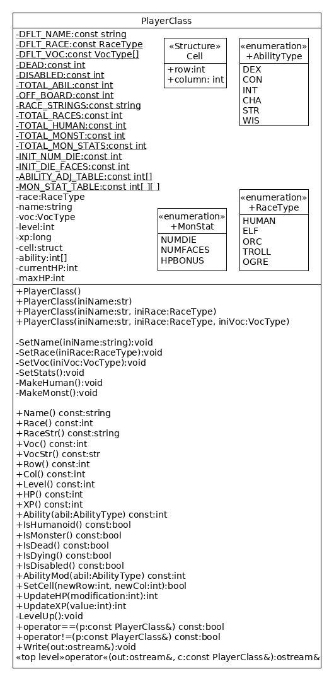

Method: void SetName(string iniName)
Narrative: Validates an inputted string and, if valid, has its value assigned to name
Pre-condition: None
Post-condition: name with a new value

- If the size of iniName < 1
  - name = DFLT_NAME
- else name = iniName

Method: void SetRace(RaceType iniRace)
Narrative: Validates an inputted RaceType and, if valid, has its value assigned to race
Pre-condition: None
Post-condition: race with a new value

- If 0 <= iniRace and iniRace < TOTAL_RACES
  - race = iniRace
- else race = DFLT_RACE

Method: void SetVoc(VocType iniVoc)
Narrative: Validates an inputted VocType and, if valid, has its value assigned to voc
Pre-condition: None
Post-condition: voc with a new value

- If 0 <= iniVoc and iniVoc < NUM_VOC
  - voc = iniVoc
- else voc = DFLT_VOC

Method: void MakeHuman()
Narrative: Initializes stats for a humanoid PlayerClass
Pre-condition: None
Post-condition: ability, currentHP, and maxHP initialized

- While i is less than TOTAL_ABIL
  - ability[i] = Roll(name, i, INIT_NUM_DIE, INIT_DIE_FACES)
  - ability[i] = ability[i] + ABILITY_ADJ_TABLE[race][i]
- maxHP = Roll(name, RollType::HP, INIT_NUM_DIE, HitDie(voc)) + AbilityMod(CON)
- currentHP = maxHP

Method: void MakeMonst()
Narrative: Initializes stats for monster PlayerClass
Pre-condition: None
Post-condition: ability, currentHP, and maxHP are all initialized.

- While i is less than TOTAL_ABIL
  - ability[i] = MON_STAT_TABLE[race][i]
- maxHP = Roll(name, RollType::HP, MON_STAT_TABLE[race-TOTAL_HUM][NUMDIE], MON_STAT_TABLE[race-TOTAL_HUM][NUMFACES]) + MON_STAT_TABLE[race-TOTAL_HUM][HPBONUS]
- currentHP = maxHP

Method: void SetStats()
Narrative: Initializes stats for the PlayerClass
Pre-condition: None
Post-condition: Level, xp, currentHP, maxHP, cell, and ability are all initialized.

- Level = 1
- xp = 0
- SetCell(OFF_BOARD, OFF_BOARD)
- if IsHuman()
  - MakeHum()
- else
  - MakeMonst()

Method: bool SetCell(int newRow, int newCol)
Narrative: Updates the player’s current coordinates regardless of other fields.
Pre-condition: newRow and newCol must either both equal -1 or be greater than or equal to 0.
Post-condition: If coordinates are set the function returns true. In all other cases the function returns false.

- If newRow is equal to newCol and newRow is equal to OFF_BOARD
  - cell.row = OFF_BOARD
  - cell.column = OFF_BOARD
- else if newRow is greater than -1 and newCol is greater than -1
  - cell.row = newRow
  - cell.column = newCol
- else
  - return false

Method: PlayerClass()
Narrative: Creates a player with the default values
Pre-condition: None
Post-condition: A PlayerClass initialized to the default values

- SetName(DFLT_NAME)
- SetRace(DFLT_RACE)
- SetVoc(DFLT_VOC[race])
- SetCell(OFF_BOARD, OFF_BOARD)
- SetStats()

Method: PlayerClass(string iniName)
Narrative: Creates a player with the specified name
Pre-condition: None
Post-condition: A PlayerClass initialized with the specified name and the rest the default values

- SetName(iniName)
- SetRace(DFLT_RACE)
- SetVoc(DFLT_VOC[race])
- SetCell(OFF_BOARD, OFF_BOARD)
- SetStats()
Method: PlayerClass(string iniName, RaceType iniRace)
Narrative: Creates a player with the specified name and race
Pre-condition: None
Post-condition: A PlayerClass initialized with the specified name and race, with the rest the default values

- SetName(iniName)
- SetRace(iniRace)
- SetVoc(DFLT_VOC[race])
- SetCell(OFF_BOARD, OFF_BOARD)
- SetStats()

Method: PlayerClass(string iniName, RaceType iniRace, VocType iniVoc)
Narrative: Creates a player with the given attributes, as long as they’re valid
Pre-condition: None
Post-condition: A PlayerClass initialized to the specified values

- SetName(iniName)
- SetRace(iniRace)
- SetVoc(iniVoc)
- SetCell(OFF_BOARD, OFF_BOARD)
- SetStats()

Method: bool IsHuman()
Narrative: Determines if the character is humanoid or not
Pre-condition: None
Post-condition: True if the character is humanoid and false if they’re not

- Return race < TROLL

Method: bool IsMonster()
Narrative: Determines if the character is a monster or not
Pre-condition: None
Post-condition: True if the character is a monster and false if they’re not

- Return race >= TROLL

Method: string Name() const
Narrative: returns the player’s name
Pre-condition: None
Post-condition: the player’s name is returned. No other changes are made

- Return name

Method: RaceType Race() const
Narrative: returns the player’s race
Pre-condition: None
Post-condition: the player’s race is returned. No other changes are made

- Return race

Method: String RaceStr()
Narrative: Returns the player’s race as a string
Pre-condition: none
Post-condition: A string in all caps with no spaces

- return RACE_STRINGS[race]

Method: VocType Voc() const
Narrative: returns the player’s vocation
Pre-condition: None
Post-condition: the player’s vocation is returned. No other changes are made

- Return voc

Method: String VocStr()
Narrative: Returns the player’s vocation as a string
Pre-condition: none
Post-condition: A string in all caps with no spaces

- return VOC_STR[voc]

Method: int Row() const
Narrative: returns the player’s row
Pre-condition: None
Post-condition: the player’s row is returned. No other changes are made

- Return cell.row

Method: int Col() const
Narrative: returns the player’s column
Pre-condition: None
Post-condition: the player’s column is returned. No other changes are made

- Return cell.column

Method: int Level() const
Narrative: returns the player’s level
Pre-condition: None
Post-condition: the player’s level is returned. No other changes are made

- Return level

Method: long XP() const
Narrative: returns the player’s xp
Pre-condition: None
Post-condition: the player’s xp is returned. No other changes are made

- Return xp

Method: int Ability(AbilityType abil) const
Narrative: returns the player’s stat in a specified ability
Pre-condition: None
Post-condition: the player’s stat in an ability is returned. No other changes are made

- If 0 <= abil and abil < TOTAL_ABIL
  - stat = ability[abil]
- else
  - return ExceptionType::INVALID_ABILITY

Method: bool IsDead()
Narrative: Determines if the character is dead or not
Pre-condition: None
Post-condition: True if the character’s currentHP is equal to or below DEAD or if their constitution is below 0 and false if they’re not

- if currentHP =< DEAD
  - dead = true
- if ability[CON] == 0
  - dead = true

Method: bool IsDying()
Narrative: Determines if the character is dying or not
Pre-condition: None
Post-condition: True if the character’s currentHP is below DISABLED but above DEAD and false if they’re not

- Return DISABLED > currentHP and currentHP > DEAD

Method: bool IsDisabled()
Narrative: Determines if the character is disabled or not
Pre-condition: None
Post-condition: True if the character’s currentHP is below DISABLED and false if they’re not

- Return currentHP <= DISABLED

Method: int AbilityMod(AbilityType abil) const
Narrative: Calculates the ability modifier based off of the player’s ability stat and returns it
Pre-condition: None
Post-condition: The ability modifier is returned and no other changes occurred

- baseAbil = ability[abil]
- if baseAbil != ExceptionType::INVALID_ABILITY
  - mod = floor((baseAbil / 2) – 5) //round the value down
- else

Method: int UpdateHP(int modification)
Narrative: Updates the player’s XP by modification. A positive value will increase HP up to maxHP. If value is less than zero, the HP is decreased.
Pre-condition: None
Post-condition: The updated HP is returned

- return currentHP + modification

Method: long UpdateXP(int value)
Narrative: Updates the player’s XP by value. A positive value will increase XP. An increase in XP could cause a humanoid to be promoted to the next level within their vocation. If value is less than zero, the XP is unchanged.
Pre-condition: None
Post-condition: The updated XP is returned

- If IsHuman()
  - If value > 0
    - xp = xp + value
  - while xp >= XPforPromotion(level+1)
    - LevelUp()
- return xp

Method: void LevelUp()
Narrative: Handles the changes in a characters stats when they level up
Pre-condition: None
Post-condition: Level will have been increased by 1 and hp will have been increased

- level++
- maxHP = maxHP + Roll(name, RollType::HP, 1, HitDie(vocation)) + AbilityMod(CON);
- currentHP = maxHP

Method: operator bool ==(const PlayerClass& p) const
Narrative: compares the player to another player to see if they’re the same
Pre-condition: None
Post-condition: Returns true if they have the same name and false otherwise

- If Ucase(name) == Ucase(p.Name())
  - same = true
- else
  - same = false

Method: operator bool !=(const PlayerClass& p) const
Narrative: compares the player to another player to see if they’re different
Pre-condition: None
Post-condition: Returns true if they have different names and false otherwise

- If Ucase(name) != Ucase(p.Name())
  - different = true
- else
  - different = false

Method: void Write(ostream& out)
Narrative: Outputs the player’s data
Pre-condition: None
Post-condition: outputs the data with # separating the different parts

- OutString = RACE_STRINGS[race] + ‘#‘
- OutString = OutString + VOC_STRING[voc] + ‘#’
- OutString = OutString + level + ‘#’
- OutString = OutString + name + ‘#’
- OutString = OutString + cell.row + ‘#’ + cell.column+ ‘#’
- OutString = OutString + currentHP + ‘#’ + maxHP + ‘#’
- while I < TOTAL_ABIL
  - OutString = OutString + ability[i] + ‘#’
- OutString = OutString + xp

